PROJECT PLANNING PHASE

Project Planning (Product Backlog, Sprint Planning, Stories, Story points)

|  |  |
| --- | --- |
| **Date** | **24 October 2022** |
| **Team ID** | **PNT2022TMID30005** |
| **Project Name** | **Analysis of crop yield prediction using data mining techniques** |
| **Maximum Marks** | **8 Marks** |

**Product Backlog, Sprint Schedule, and Estimation (4 Marks)**

|  |  |  |  |  |  |  |
| --- | --- | --- | --- | --- | --- | --- |
| **Sprint** | **Functional Requirement(Epic)** | **User**  **Story Number** | **User Story / Task** | **Story Points** | **Priority** | **Team Members** |
| **Sprint-1** | Training data | USN-1 | The training data set is a set of data used to discover predictive relationship. Training set is used in intelligent system ,machine learning,genetic programming and statistics. | 2 | High | Aishwarya  Sandhiya  Sunitha  Tharani |
| **Sprint-1** | Testing Data | USN-2 | Test data is the input given to a software program.it represents data that affects or is affected by the execution of the specific module. | 3 | High | Aishwarya  Sandhiya  Sunitha  Tharani |
| **Sprint-2** | Data Exploration | USN-3 | As a user, I can view the visualized data to get the better understanding about the soil nutrients, weather and past production of crop. | 8 | High | Aishwarya  Sandhiya  Sunitha  Tharani |
| **Sprint-3** | Dashboard Creation | USN-4 | As a user, I can view the different visualization in the dashboard creation. | 8 | High | Aishwarya  Sandhiya  Sunitha  Tharani |

|  |  |  |  |  |  |  |
| --- | --- | --- | --- | --- | --- | --- |
| **Sprint** | **Functional Requirement (Epic)** | **User Story Number** | **User Story / Task** | **Story Points** | **Priority** | **Team Members** |
| **Sprint-4** | Report creation | USN-5 | As a user, I can view the detailed report of the soil nutrients, weather changes etc. The user can get the report of the particular  data. | 8 | High | Aishwarya  Sandhiya  Sunitha  Tharani |
| **Sprint-4** | Story creation | USN-6 | As a user, I can view the story to get the better understanding of the crops  . The user can make decisions based on the story. | 8 | High | Aishwarya  Sandhiya  Sunitha  Tharani |

**Project Tracker, Velocity & Burndown Chart: (4 Marks)**

|  |  |  |  |  |  |  |
| --- | --- | --- | --- | --- | --- | --- |
| **Sprint** | **Total Story Points** | **Duration** | **Sprint Start Date** | **Sprint End Date (Planned)** | **Story Points Completed (as on Planned End**  **Date)** | **Sprint Release Date(Actual)** |
| **Sprint-1** | 5 | 6 Days | 24 Oct 2022 | 29 Oct 2022 | 5 | 29 Oct 2022 |
| **Sprint-2** | 8 | 6 Days | 31 Oct 2022 | 05 Nov 2022 | 8 | 05 Nov 2022 |
| **Sprint-3** | 8 | 6 Days | 07 Nov 2022 | 12 Nov 2022 | 8 | 12 Nov 2022 |
| **Sprint-4** | 16 | 6 Days | 14 Nov 2022 | 19 Nov 2022 | 16 | 19 Nov 2022 |

**Velocity:**

Imagine we have a 10-day sprint duration, and the velocity of the team is 20 (points per sprint). Let’s calculate the team’s average velocity (AV) per iteration unit (story points per day)

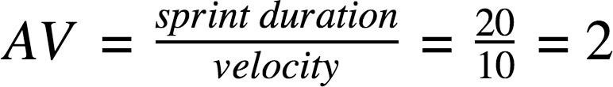

|  |  |  |  |
| --- | --- | --- | --- |
| **Sprint** | **Story points** | **Duration** | **Average velocity** |
| **Sprint-1** | 5 | 6 | **0.83** |
| **Sprint-2** | 8 | 6 | **1.33** |
| **Sprint-3** | 8 | 6 | **1.33** |
| **Sprint-4** | 16 | 6 | **2.66** |
| **Total** | **37** | **24** | **1.54** |

**project planning:**

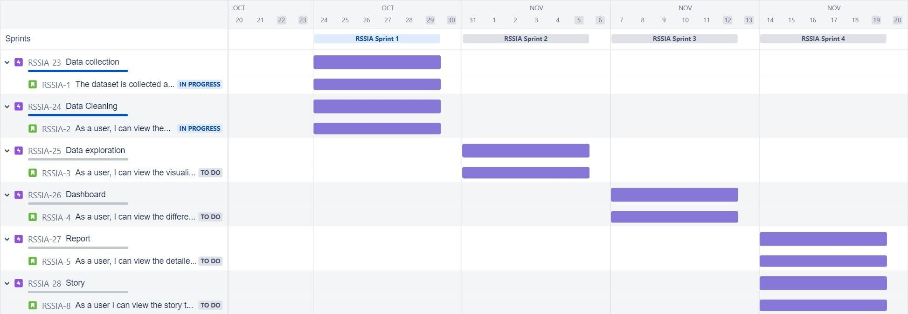

**Chart:**

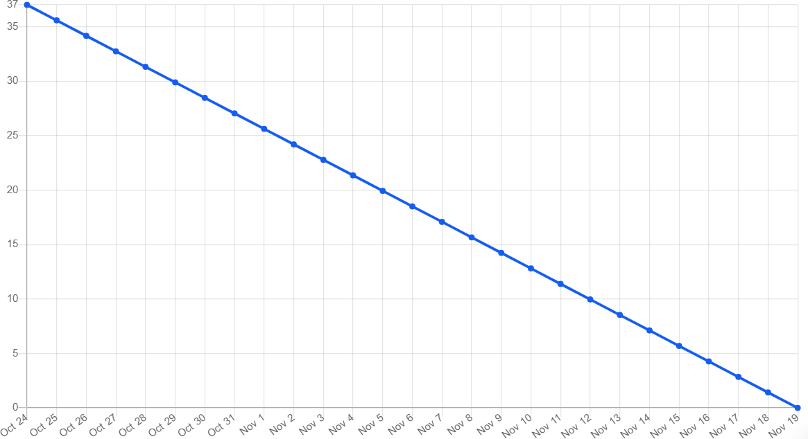

**Sprint-1**

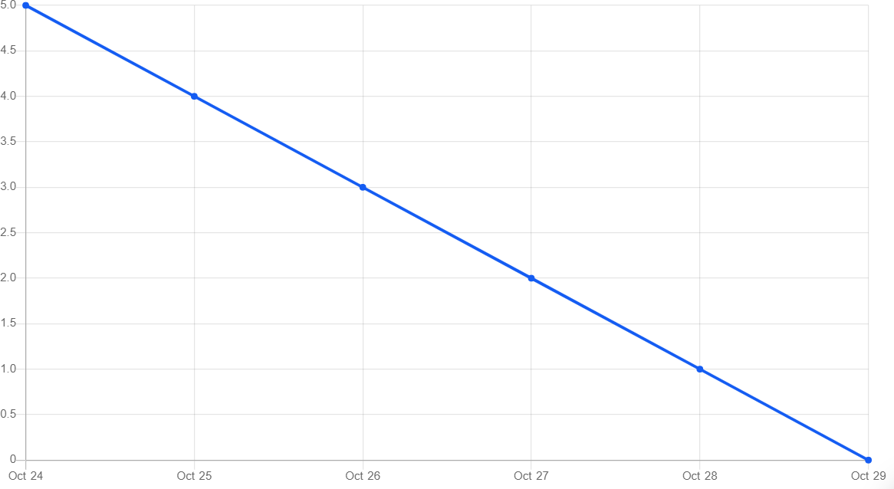

**Sprint-2**

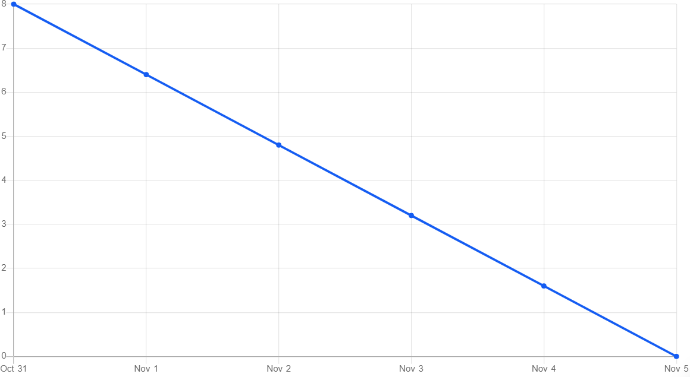

**Sprint-3**

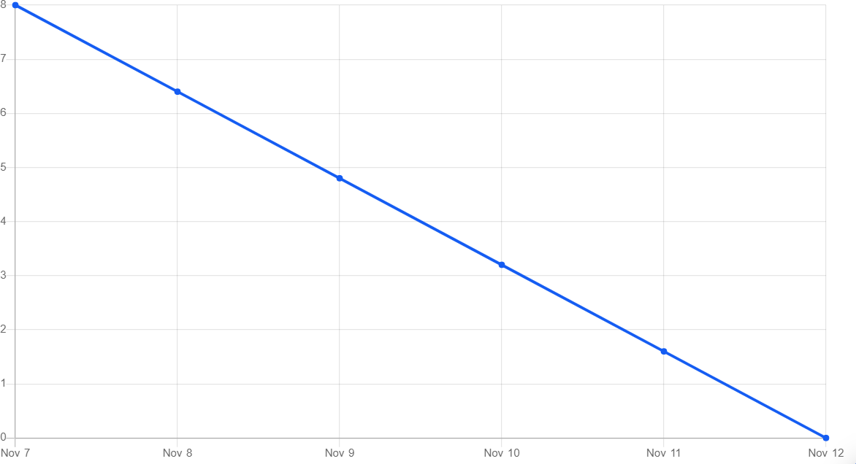

**Sprint-4**

